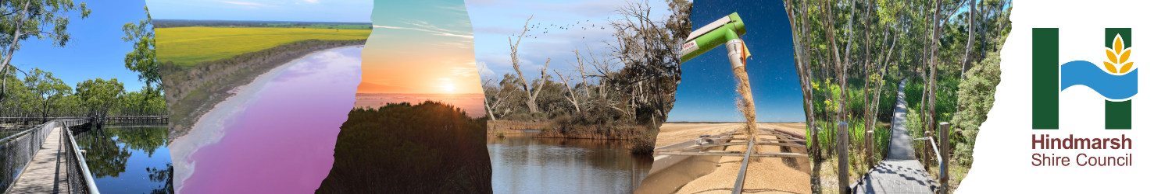

Hindmarsh Shire Council
Our services are for everyone in the community.
Contacting Council | Phone number: (03) 5391 4444  Email: info@hindmarsh.vic.gov.au  Postal Address: PO Box 250, Nhill VIC 3418  Nhill Office: 92 Nelson Street, Nhill  Dimboola Office: 101 Lloyd Street, Dimboola  Rainbow Office: 49 Federal Street, Rainbow  Jeparit Office: 10 Roy Street, Jeparit
Languages Other Than English | If you need to talk to Council and speak a language other than English, you can call the Translating and Interpreting Service on 131 450.
Councillors | Council has six elected Councillors who represent the community. You can contact your Councillor to talk about your community or ask questions about Hindmarsh Shire. To find out who your Councillors are visit the Hindmarsh Shire Council website: www.hindmarsh.vic.gov.au/Council/Councillors
Rates | Rates are paid by all property owners within Hindmarsh to help pay for more than 100 services provided by Council. Annual Rates Notices are sent to property owners in August each year.
Rubbish | Council provides street collection services in Nhill, Jeparit, Rainbow and Dimboola. This includes a general waste bin (red lid) that is collected every week, a recycling bin (yellow lid) that is collected every two weeks and a glass bin (purple lid) that is collected every eight weeks.  There are also transfer stations in all four towns where you can take green waste, furniture, e-waste, tyres, and other types of waste that doesn’t belong in your home bins.
Animal Registration | All dogs and cats within Hindmarsh Shire need to be registered. All registered animals will receive a Council tag that allows us to return them home quickly if they become lost.
Building and Planning | If you are planning on doing any building work on your property, you'll need to find out whether your project requires a planning permit, a building permit, or both. Contact us for more information.
Community Wellbeing | Council runs events and programs for people of all ages to help them enjoy living in our community, this includes for children, teenagers, adults and the elderly.
Supported Playgroup | Playgroup caters for children from birth to school age. Parents and children can come every week to encourage a positive place to learn, explore and grow.
Kindergartens | Three- and four-year-old educational Kindergarten programs for children prior to school entry in Hindmarsh Shire. All enquiries may be directed to the Horsham and District Kindergarten Association on 03 5382 7997.
Local Laws and Rules | Hindmarsh has Local Laws that keep our community safe for everyone. Our Local Laws cover things like camping, using public spaces, noise and permits.
Libraries | Council has libraries in Nhill, Jeparit, Dimboola and Rainbow. You can borrow and requests books, DVDs, magazines, or you can use free computers and WIFI.
Reporting an Issue | If you would like to report an issue about a road, public space or Council service, you can contact us. If you would like to make a complaint, you can also contact us, and we can either respond to the complaint or get you in contact with someone who can help you with the complaint.
Business Support | Council can help people who want to start a business in Hindmarsh Shire.
Jobs | Hindmarsh Shire is a great place to work. There are jobs where you can work inside and outside and that suit people with lots of different skills.

Please call or visit us to talk about any of our services.

